**Local-Hystrix-Eureka-Zuul-SpringBoot Demo**

**Eureka Server**

1. Move to the directory structure of eureka-server where pom.xml is present.



1. Build the eureka-server as a maven project like…

|  |
| --- |
| mvn clean install |

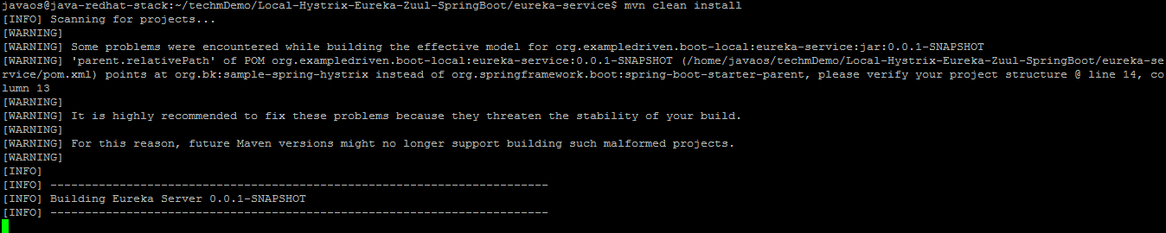

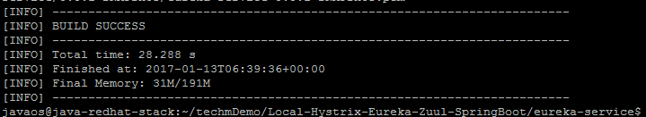

After maven build success, run the **.jar** file, move to **target** folder and run the .jar file and

|  |
| --- |
| cd target |
| java –jar eureka-service-0.0.1-SNAPSHOT.jar |

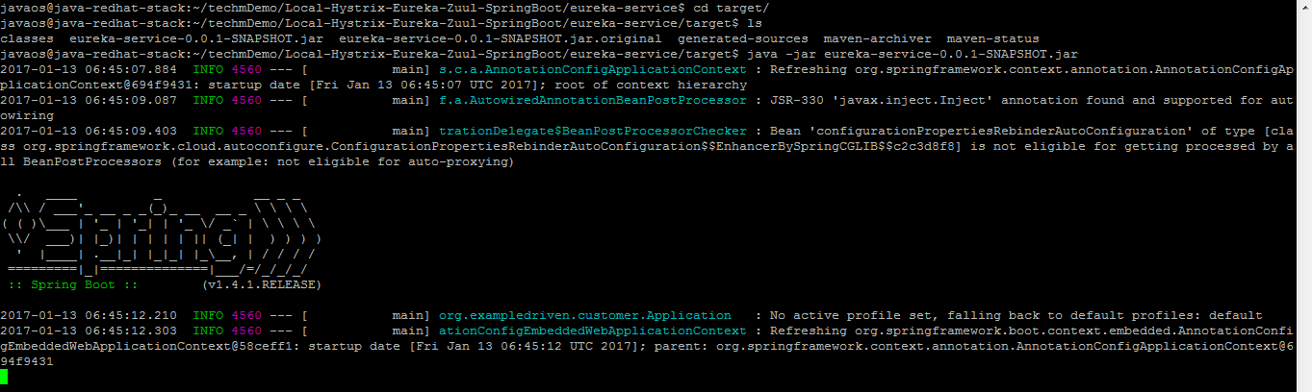

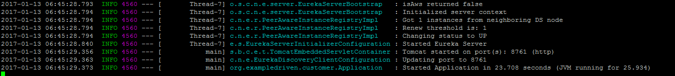

1. When the application status turns UP, access the eureka-server in the browser.

|  |
| --- |
| <http://13.76.98.121:8761/> |

**Eureka Dashboard**

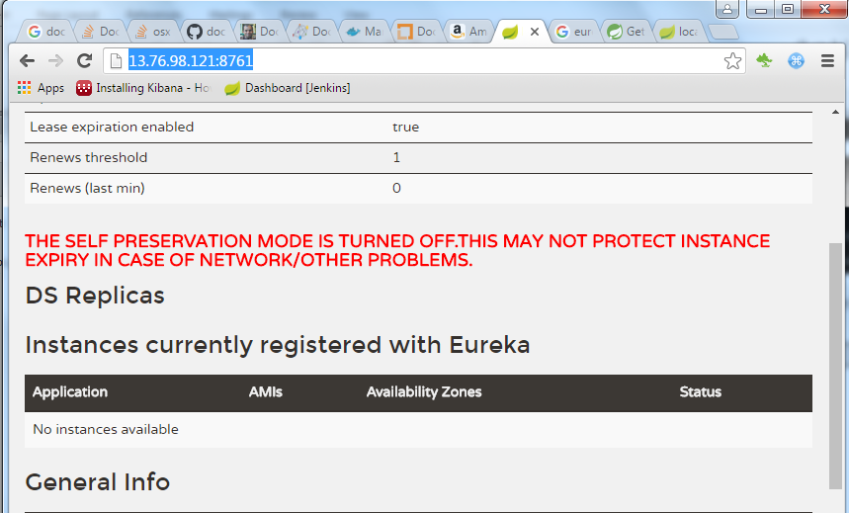

Eureka dashboard with no running applications.

**Db-Operation-Service**

1. Move to the directory structure of eureka-server where pom.xml is present.

|  |
| --- |
| cd db-operation-service |

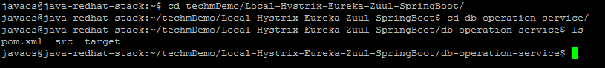

1. Build the db-operation-service as a maven project.

|  |
| --- |
| mvn clean install |

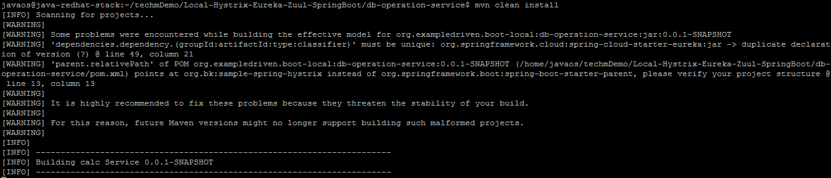

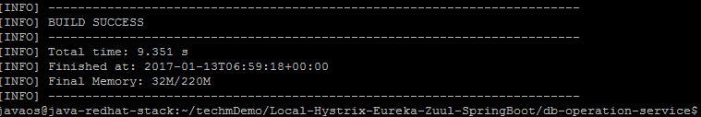

1. Run the application by running the **.jar** file in the **target** folder.

|  |
| --- |
| cd target |
| Java –jar db-operation-service-0.0.1-SNAPSHOT.jar |

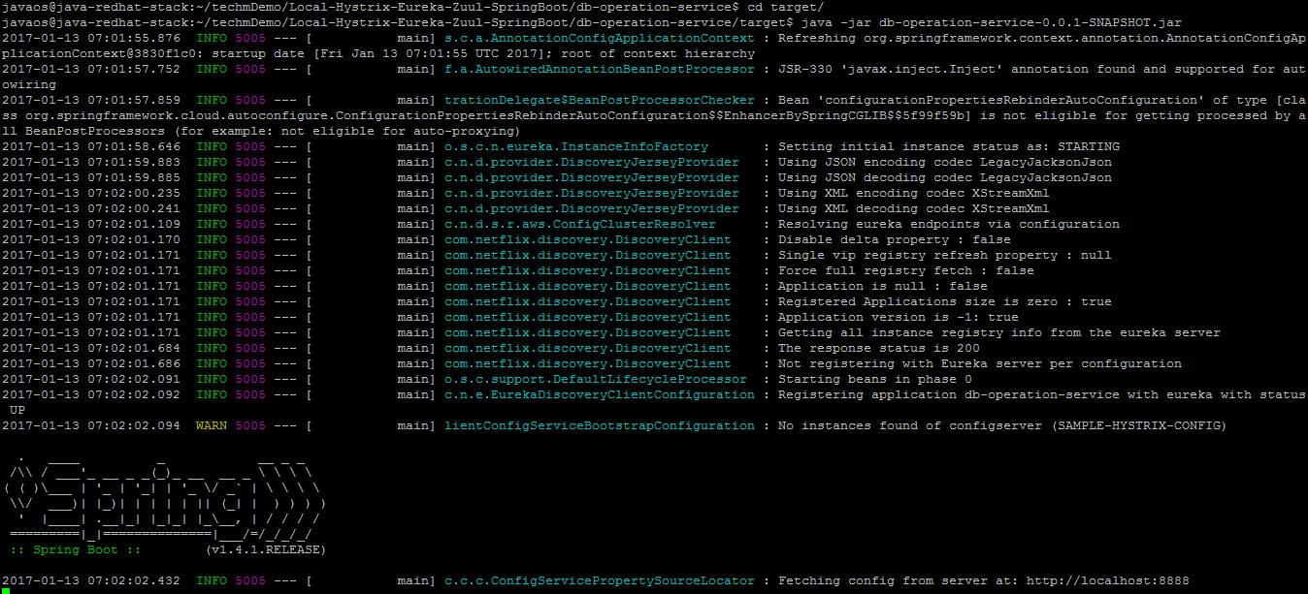

1. When the db-operation-service started, go to the browser and refresh the eureka browser.

|  |
| --- |
| <http://13.76.98.121:8761/> |

**Eureka Dashboard**

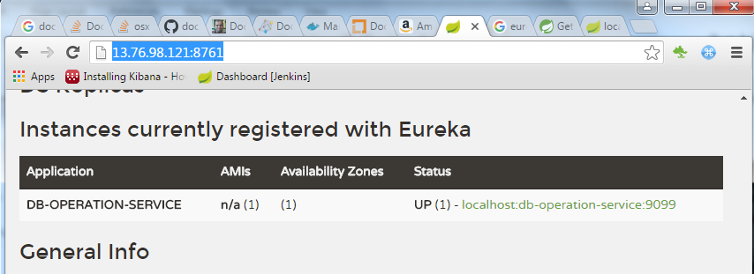

The dashboard shows the running application, db-operation-service.

1. Access the application in the browser.

|  |
| --- |
| <http://13.76.98.121:9099/insert> |
| <http://13.76.98.121:9099/update> |
| <http://13.76.98.121:9099/delete> |

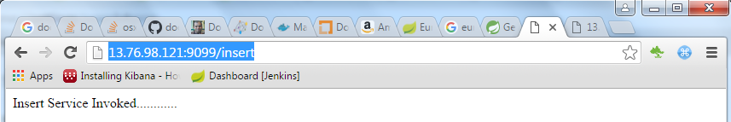

**Zuul Server**

1. Move to the directory structure of eureka-server where pom.xml is present.

|  |
| --- |
| cd zuul-server |



1. Build the zuul-server application as a maven project.

|  |
| --- |
| mvn clean install |

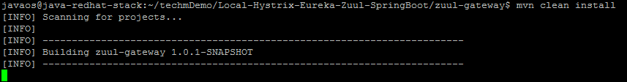

1. Run the application by running the .**jar** file in the **target** folder.

|  |
| --- |
| cd target |
| java –jar zuul-gateway-1.0.1-SNAPSHOT.jar |

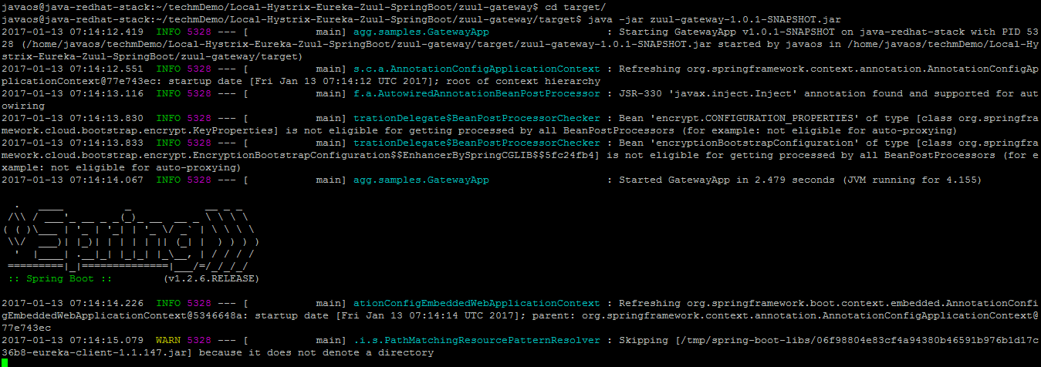

1. When the application starts, refresh the eureka browser.

|  |
| --- |
| <http://13.76.98.121:8761/> |

**Eureka Dashboard**

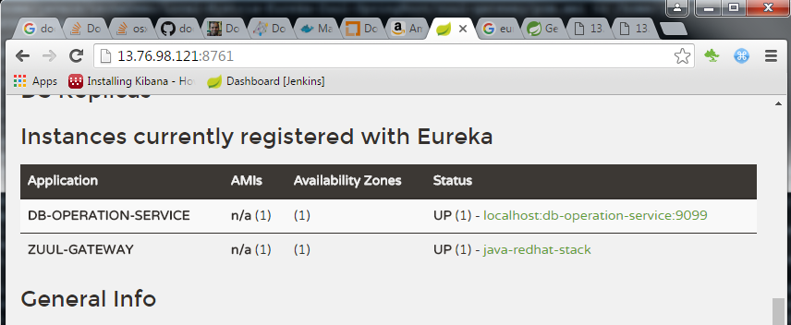

Eureka dashboard showing both db-operation-service and zuul.

1. Access the db-operation-service via zuul in the browser.

|  |
| --- |
| <http://13.76.98.121:8080/db-operation-service/insert> |
| <http://13.76.98.121:8080/db-operation-service/update> |
| <http://13.76.98.121:8080/db-operation-service/delete> |

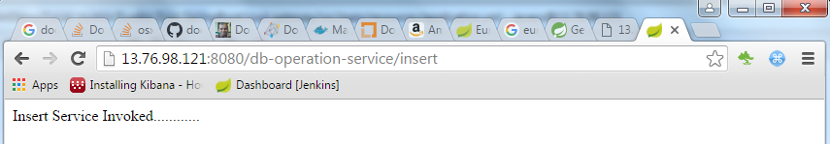

**Hystrix Monitoring**

1. Move to the directory structure of eureka-server where pom.xml is present.

|  |
| --- |
| cd sample-hystrix-monitor/ |



1. Build the application as a maven project.

|  |
| --- |
| mvn clean install |

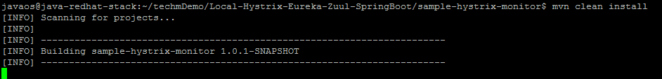

1. Run the application by running the .**jar** file in the **target** folder.

|  |
| --- |
| cd target |
| java –jar sample-hystrix-monitor-1.0.1-SNAPSHOT.jar |

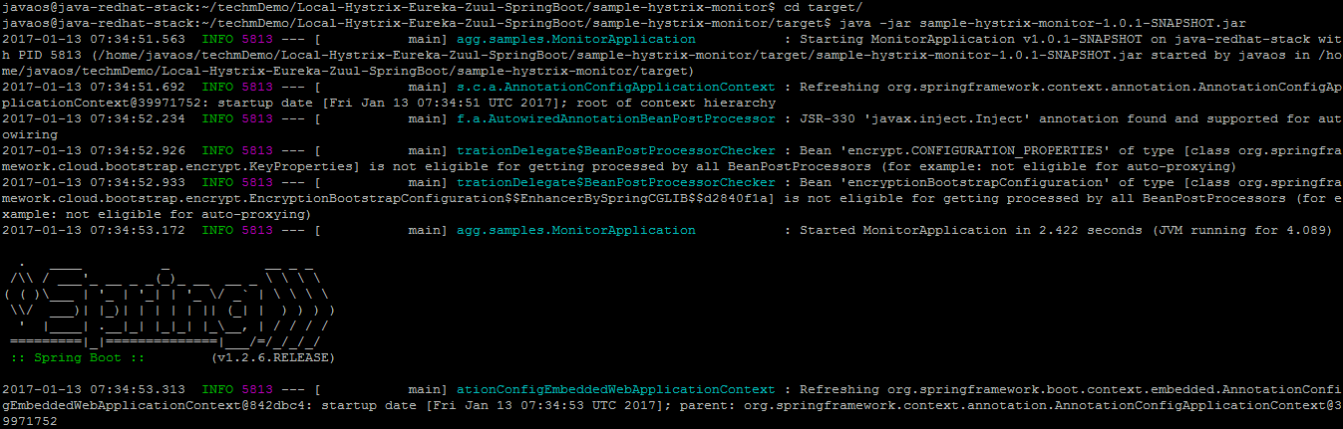

1. Refresh the eureka dashboard in browser after hystrix-server starts.

**Eureka Dashboard**

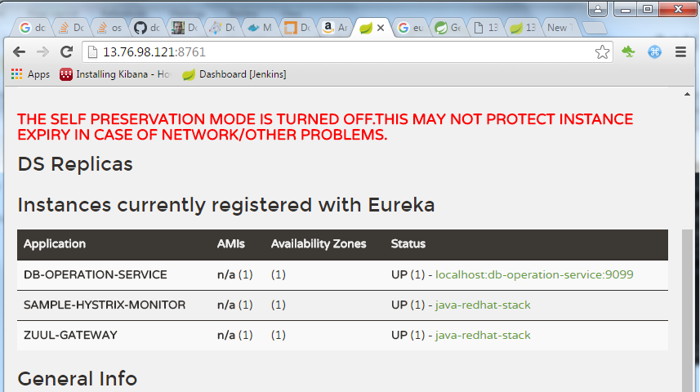

Eureka dashboard with hystrix-server running.

1. Access the hystrix dashboard in the browser by

|  |
| --- |
| <http://13.76.98.121:8989/hystrix> |

**Hystrix Dashboard**

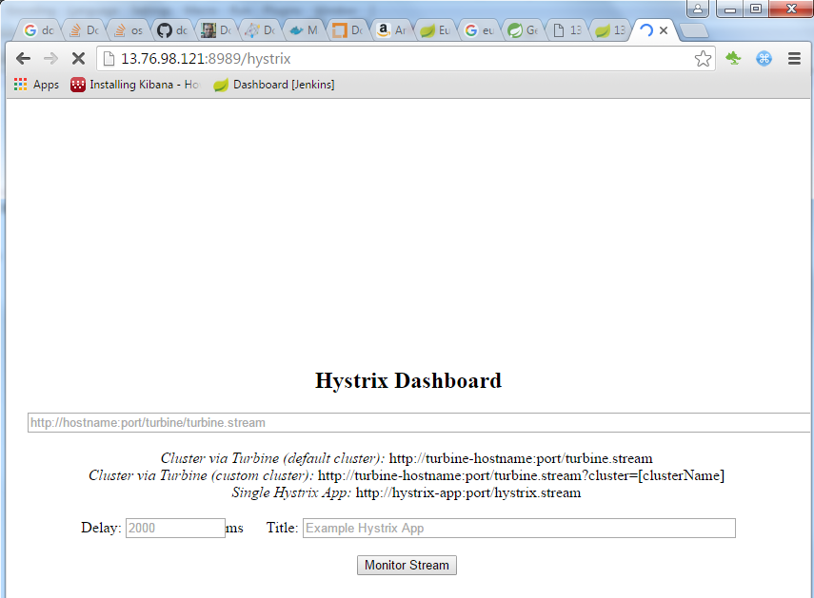

In the hystrix dashboard enter the turbine.stream url ,

|  |
| --- |
| <http://13.76.98.121:8989/turbine.stream?cluster=DB-OPERATION-SERVICE> |

Hit any of the db-operation-service , like insert/update/delete and see the status of the service in the hystrix dashboard.

**Hystrix Dashboard with Monitoring**

